StayingAPI Hotel Lookup Proof of Concept Findings Report
Project: AI Travel Assistant for Accessible Aviation (Your Accessible Flight)
Prepared by: Aindrila Das Prapti
Role: Developer
Date: 13 September 2026
Purpose
The purpose of this task was to create a proof-of-concept program that retrieves hotels near a city or airport using StayingAPI. The task also required Booking.com-only results, support for asynchronous responses, consistent response mapping, error handling, testing with real destinations, and documentation of relevant findings for Sprint 2 development.
StayingAPI Setup
I registered for a StayingAPI account and created an API key for making live hotel-search requests. The account included a limited number of complimentary credits, and each live search consumed some of these credits. The key was stored securely in a local .env file using the following variable:
STAYINGAPI_KEY=your_actual_api_key
The .env file is excluded through .gitignore, preventing the real API key from being committed to GitHub. A placeholder was added to .env.example so other developers can configure the project safely.
Proof of Concept Implementation
I created a Node.js command-line program named hotel-lookup.js. The program accepts a city or airport as input and requests relevant hotel information from StayingAPI.
Example commands include:
npm run hotel -- "Melbourne"
npm run hotel -- "Sydney Airport"
npm run hotel -- "Sibu" --limit 3
The program restricts results to Booking.com by including:
platforms=booking
The API connection and response-handling logic were separated into lib/stayingapi.js. This keeps the API logic reusable if the hotel search is later integrated into the chatbot backend.
Asynchronous Response Handling
During all three live tests, StayingAPI initially returned a 202 Accepted response. This means the search was accepted but the results were still being prepared.
The program handles this process by:
- Sending the hotel search request.
- Reading the job ID from the 202 response.
- Polling the job endpoint every three seconds.
- Continuing until the job completes or fails.
- Stopping after five minutes if the job does not finish.
- Processing and displaying the completed results.
The terminal displays the following message while waiting:
Search is still processing. Waiting for results...
This confirmed that asynchronous polling is required when using StayingAPI for live hotel searches.
Response Mapping
The provider response is mapped into a consistent structure containing:
- Hotel ID
- Hotel name
- Location
- Nightly price where available
- Total price where available
- Currency
- Rating where available
- Booking URL
- Platform
The program also accepts alternative provider field names where possible. This helps prevent small response-format differences from breaking the program.
If an optional value is missing, the program displays a clear placeholder instead of failing. For example:
Price: Price unavailable
Rating: Unavailable
The final field structure should be compared with the client backend’s external-service schema during Sprint 2 integration.
Live Testing
I tested the proof of concept using three real destinations.
Melbourne
The Melbourne search returned:
- The Savoy Hotel on Little Collins Melbourne
- Grand Hyatt Melbourne
- Citadines on Bourke Melbourne
All three results included a hotel name, address and Booking.com link.
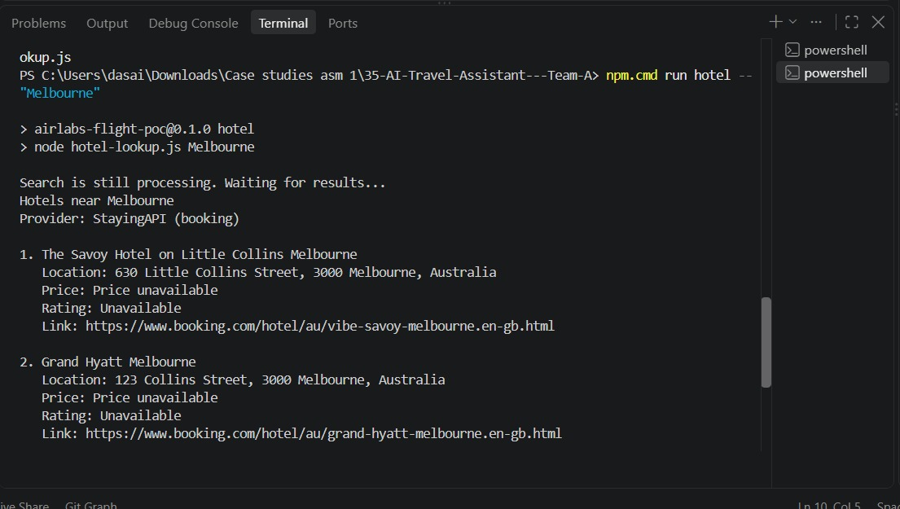Figure 1. Live hotel search results for Melbourne.
Sydney Airport
The Sydney Airport search returned:
- Rydges Sydney Airport Hotel
- Aerotel Sydney
- Meriton Suites Mascot Central
This test confirmed that the program accepts an airport as the destination and returns relevant nearby properties.

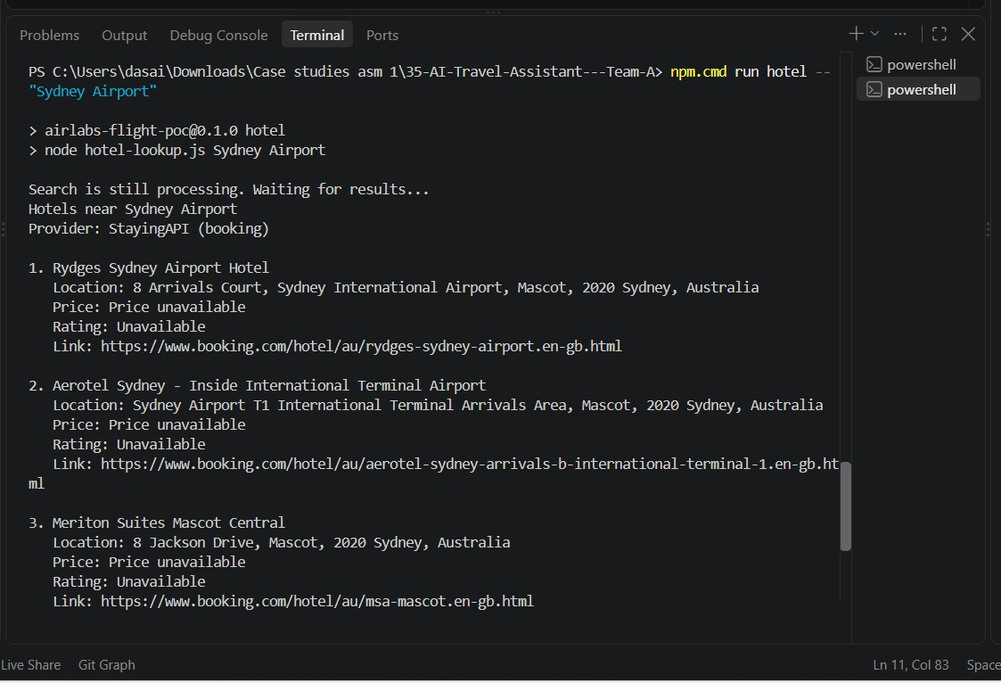Figure 2. Live hotel search results for Sydney Airport.
Sibu
The Sibu search returned:
- Starlink Hotel
- RH Hotel Sibu
- Kingwood Hotel Sibu
This test produced relevant Booking.com properties for an international destination.
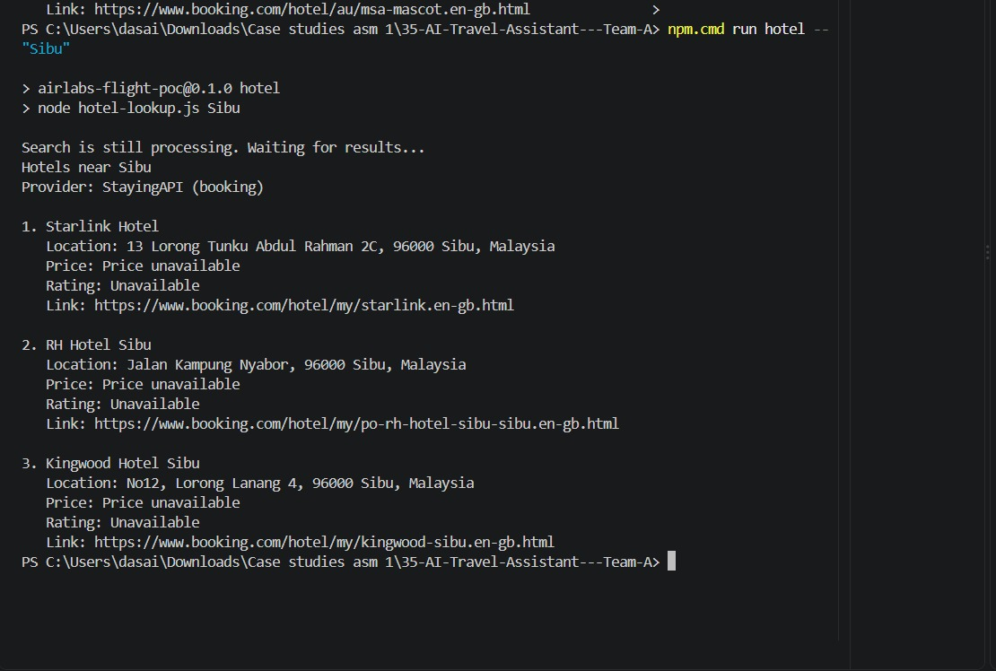Figure 3. Live hotel search results for Sibu.
Prices and ratings were unavailable in all three tested responses. However, the program handled the missing values correctly and continued displaying the available hotel information.
Error Handling
The proof of concept includes handling for the following conditions:
- Missing destination input
- Invalid destination input
- No hotel results
- API authentication errors
- Unsuccessful API responses
- Network failures
- Invalid JSON responses
- Individual request timeouts
- Failed asynchronous jobs
- Asynchronous jobs that remain pending for too long
I manually tested the missing-input case by running:
node hotel-lookup.js
The program returned a clear error and usage instructions without making an API request:
Error: Please enter a city or airport.
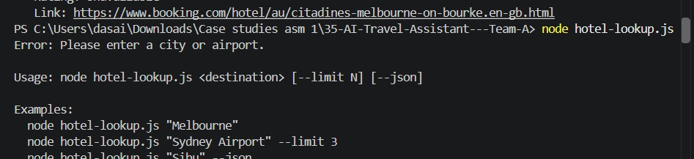Figure 4. Invalid-input handling when no destination is supplied.
Automated Testing
I created test/hotel-lookup.test.js to test the hotel lookup logic without using live API credits.
The automated tests cover:
- City and airport argument parsing
- Multi-word destinations
- Invalid or missing input
- Invalid result limits
- Hotel-field normalisation
- Price formatting
- Human-readable output
I also updated the project’s main test command so it runs both the existing flight tests and the new hotel tests:
npm test
The complete test suite passed successfully.
Key Findings and API Quirks
The following findings should be considered during Sprint 2 development:
- StayingAPI live searches may return 202 Accepted instead of immediate results.
- The backend must poll the supplied job endpoint until the search completes.
- Processing may take longer than a normal synchronous request.
- City names and airport names are both accepted as destination input.
- Using platforms=booking successfully restricts results to Booking.com.
- Hotel names, addresses and Booking.com links were consistently returned.
- Prices and ratings were not included in the three tested responses.
- Missing optional fields must be handled without failing the entire request.
- Live searches consume account credits.
- Automated tests should use sample data rather than making paid API calls.
- API keys must remain in .env and must never be committed or displayed publicly.
Files Added or Updated
The following project files were added or updated:
- hotel-lookup.js
- lib/stayingapi.js
- test/hotel-lookup.test.js
- .env.example
- package.json
- README.md
Limitations and Sprint 2 Considerations
The current implementation is a command-line proof of concept rather than a production chatbot endpoint.
During Sprint 2, the team should:
- Connect the hotel lookup function to the chatbot flow.
- Confirm that the mapped fields match the client backend’s final external-service schema.
- Decide how long the user interface should wait for a pending search.
- Decide how missing prices and ratings should be displayed.
- Determine whether search results should be cached.
- Monitor StayingAPI credit usage.
- Ensure API keys and other credentials are never written to application logs.
Conclusion
I successfully created and tested a StayingAPI hotel lookup proof of concept. The program accepts city and airport destinations, restricts results to Booking.com, handles 202 pending responses, maps results into consistent fields, and manages invalid input and API failures gracefully.
Live tests with Melbourne, Sydney Airport and Sibu each returned three relevant Booking.com properties. The implementation, automated tests and documentation provide a working foundation for integrating hotel suggestions into the chatbot during Sprint 2.
Deliverable
GitHub Pull Request:
https://github.com/s4036446/35-AI-Travel-Assistant---Team-A/pull/4
References
StayingAPI. (n.d.). Search endpoint documentation. Retrieved 13 September 2026 from https://stayingapi.com/docs/endpoints/search
StayingAPI. (n.d.). StayingAPI. Retrieved 13 September 2026 from https://stayingapi.com/

